ISTE-230 Introduction to Database & Data Modeling

## Practice Exercise # 6 – Normalization through BCNF

**Name:** Brian Zarzuela

**Problem #1**

Given the original relation (PUPPY) and functional dependencies, normalize the original and all resulting relations to BCNF. Be sure to use proper relational notation: RELATION(pkattr, attribute, *fkattr*). Include reference statements for foreign keys.

PUPPY(PuppyID, PuppyName, KennelNumber, KennelLocation)

Functional Dependencies:

PuppyID 🡺 PuppyName, KennelNumber, KennelLocation

KennelNumber 🡺 KennelLocation

**YOUR ANSWER (Final set of relations normalized to BCNF):**

PUPPY(PuppyID, PuppyName, *KennelNumber*)

PUPPY(KennelNumber) mei KENNEL(KennelNumber)

KENNEL(KennelNumber, KennelLocation)

**Problem #2**

Given the original relation (VEHICLE) and functional dependencies, normalize the original and all resulting relations to BCNF. Be sure to use proper relational notation: RELATION(pkattr, attribute, *fkattr*). Include reference statements for foreign keys.

VEHICLE

|  |  |  |  |  |  |
| --- | --- | --- | --- | --- | --- |
| VIN | Make | Model | Year | OwnerID | Owner |
| 111abc | Toyota | Corrolla | 1988 | 111223333 | Joe Smith |
| 223ahv | Ford | Windstar | 1998 | 222334444 | Bill Gates |
| 332amz | GM | GMC | 1995 | 333445555 | Tom Green |
| 876grd | Subarau | Outback | 2000 | 987654321 | Bob Jones |

VEHICLE (VIN, Make, Model, Year, OwnerID, Owner)

Functional Dependencies:

VIN 🡺 Make, Model, Year, OwnerID, Owner

OwnerID 🡺 Owner

**YOUR ANSWER (Final set of relations normalized to BCNF):**

VEHICLE(VIN, Make, Model, Year, *OwnerID*)

VEHICLE(OwnerID) mei OWNER(OwnerID)

OWNER(OwnerID, Owner)

**Problem #3**

A violation of 1NF is repeating groups – more than one attribute from same physical and logical domain (ex. author1, author2, etc.)

* + - Some examples we have worked with included this as a “fix” for multi-valued attributes.

In PE#2 there was the following:

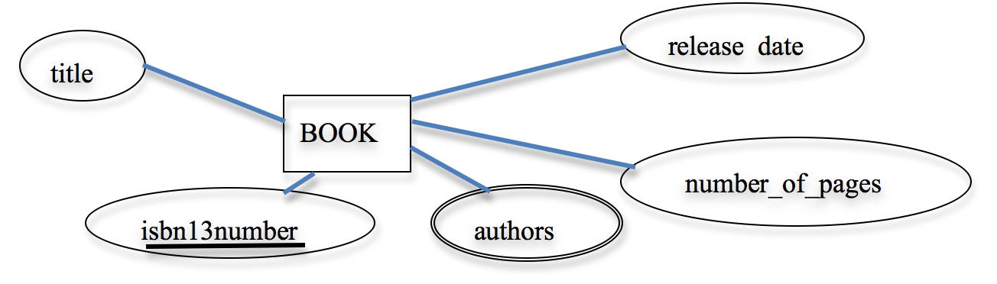

**UoD:** PE2 Book Tracking System

**Resulting Relation:** BOOK(title, isbn13number, author1, author2, author3, author4, author5, number_of_pages, release_date)

**Functional Dependencies:**

isbn13number 🡺 title, author1, author2, author3, author4, author5, number_of_pages, release_date

Finish the solution that what was started below in an effort to solve the repeating group problem. Include the modified BOOK relation that would result from the addition of the BOOK-AUTHOR relation. Use proper relational notation and include reference statements for any foreign keys.

**Unfinished Solution:**

BOOK(isbn13number, title, release_date, number_of_pages)

BOOK-AUTHOR(isbn13number, author)

**YOUR COMPLETED SOLUTION:**

BOOK(isbn13number, title, release_date, number_of_pages)

BOOK-AUTHOR(isbn13number, author)

BOOK-AUTHOR(isbn13number) mei BOOK(isbn13number)

**Problem #4**

For the relation below, determine the *highest* normal form the relation is in, the reason, and if necessary normalize through BCNF.

Relation: Q2( a, b, c, d )

Functional Dependencies:

a, b 🡪 c, d

c, d 🡪 a, b

**YOUR ANSWER:**

Relation is in BCNF because:

* It meets the criteria of a relation
* It is free from partial and transitive dependencies
* Every determinant is a candidate key

**Problem #5**

Given the original relation (A) and functional dependencies, normalize the original and all resulting relations to BCNF. Be sure to use proper relational notation: RELATION(pkattr, attribute, *fkattr*). Include reference statements for foreign keys.

A(1, 2, 3, 4, 5, 6, 7, 8, 9)

Functional Dependencies:

1, 2, 3 🡪 4, 5, 6, 7, 8, 9 (based on PK choice for A)

1🡪 4

4 🡪 1

2🡪 6, 7, 8, 9

6,7 🡪 8,9

**YOUR ANSWER (Final set of relations normalized to BCNF):**

A(1, 2, 3, 5)

A(1) mei B(1)

A(2) mei C(2)

B(1, 4)

C(2, *6, 7*)

C(6, 7) mei D(6, 7)

D(6, 7, 8, 9)